


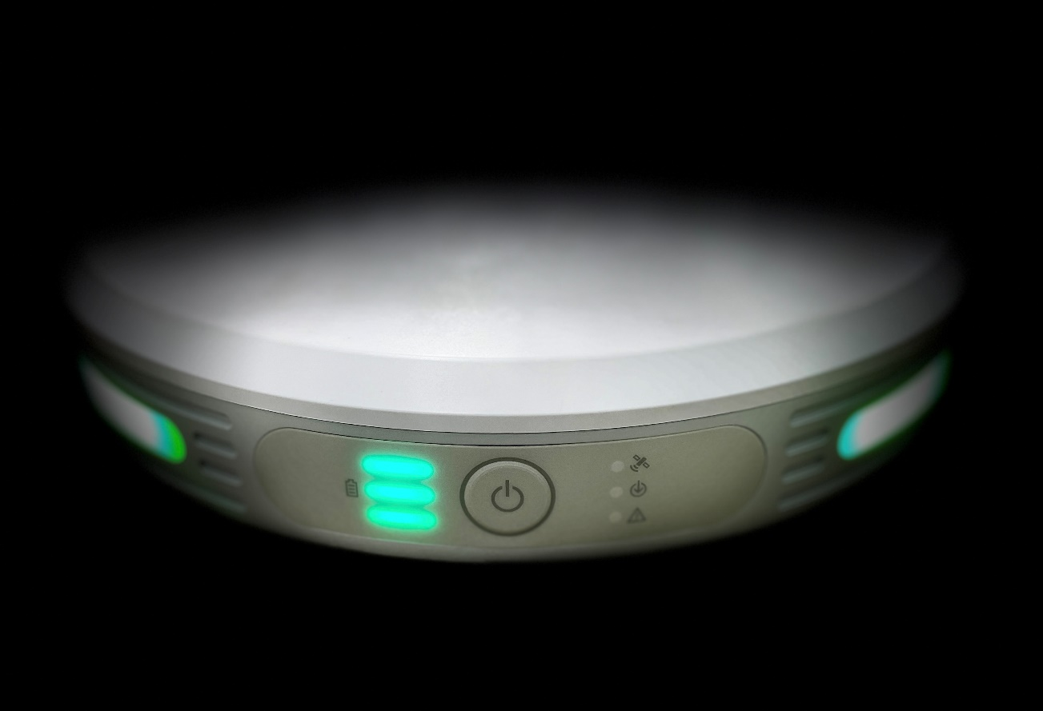

Komatsu SC Edge2 & Drone
SC-Edge2-Quick Guide-001-v1.0

Contents
Revision History 1
Drone Flight 2
Setup SC Edge2 2
Setup & Fly Drone (P4rtk) 2
P4rtk Settings: 3
Setup & Fly Drone (Mavic3E) 3
Mavic3E Settings 3
Base station Function 5
1) Processing your data 6
Appendix 9
For iPad - Install and configure certificate 9
Add a tablet app to your home screen 9
For Android or Laptop 9
Warnings & Other Notices 10
Hardware specification 15

Revision History

No. | Date | Description | Reviewed | Appr’d
1 | 01/02/2024 | First Release (Komatsu_SC_Edge2 Quick Guide Short_001_V1.0) | JM | JM
2 | 13/08/2024 | Overlap & White Balance setting | JM | JM

Drone Flight

Setup SC Edge2
- Place the Edge in Clear, Open & Elevated position. Select your project.
  - From the home screen make sure Edge is in Drone Survey Mode 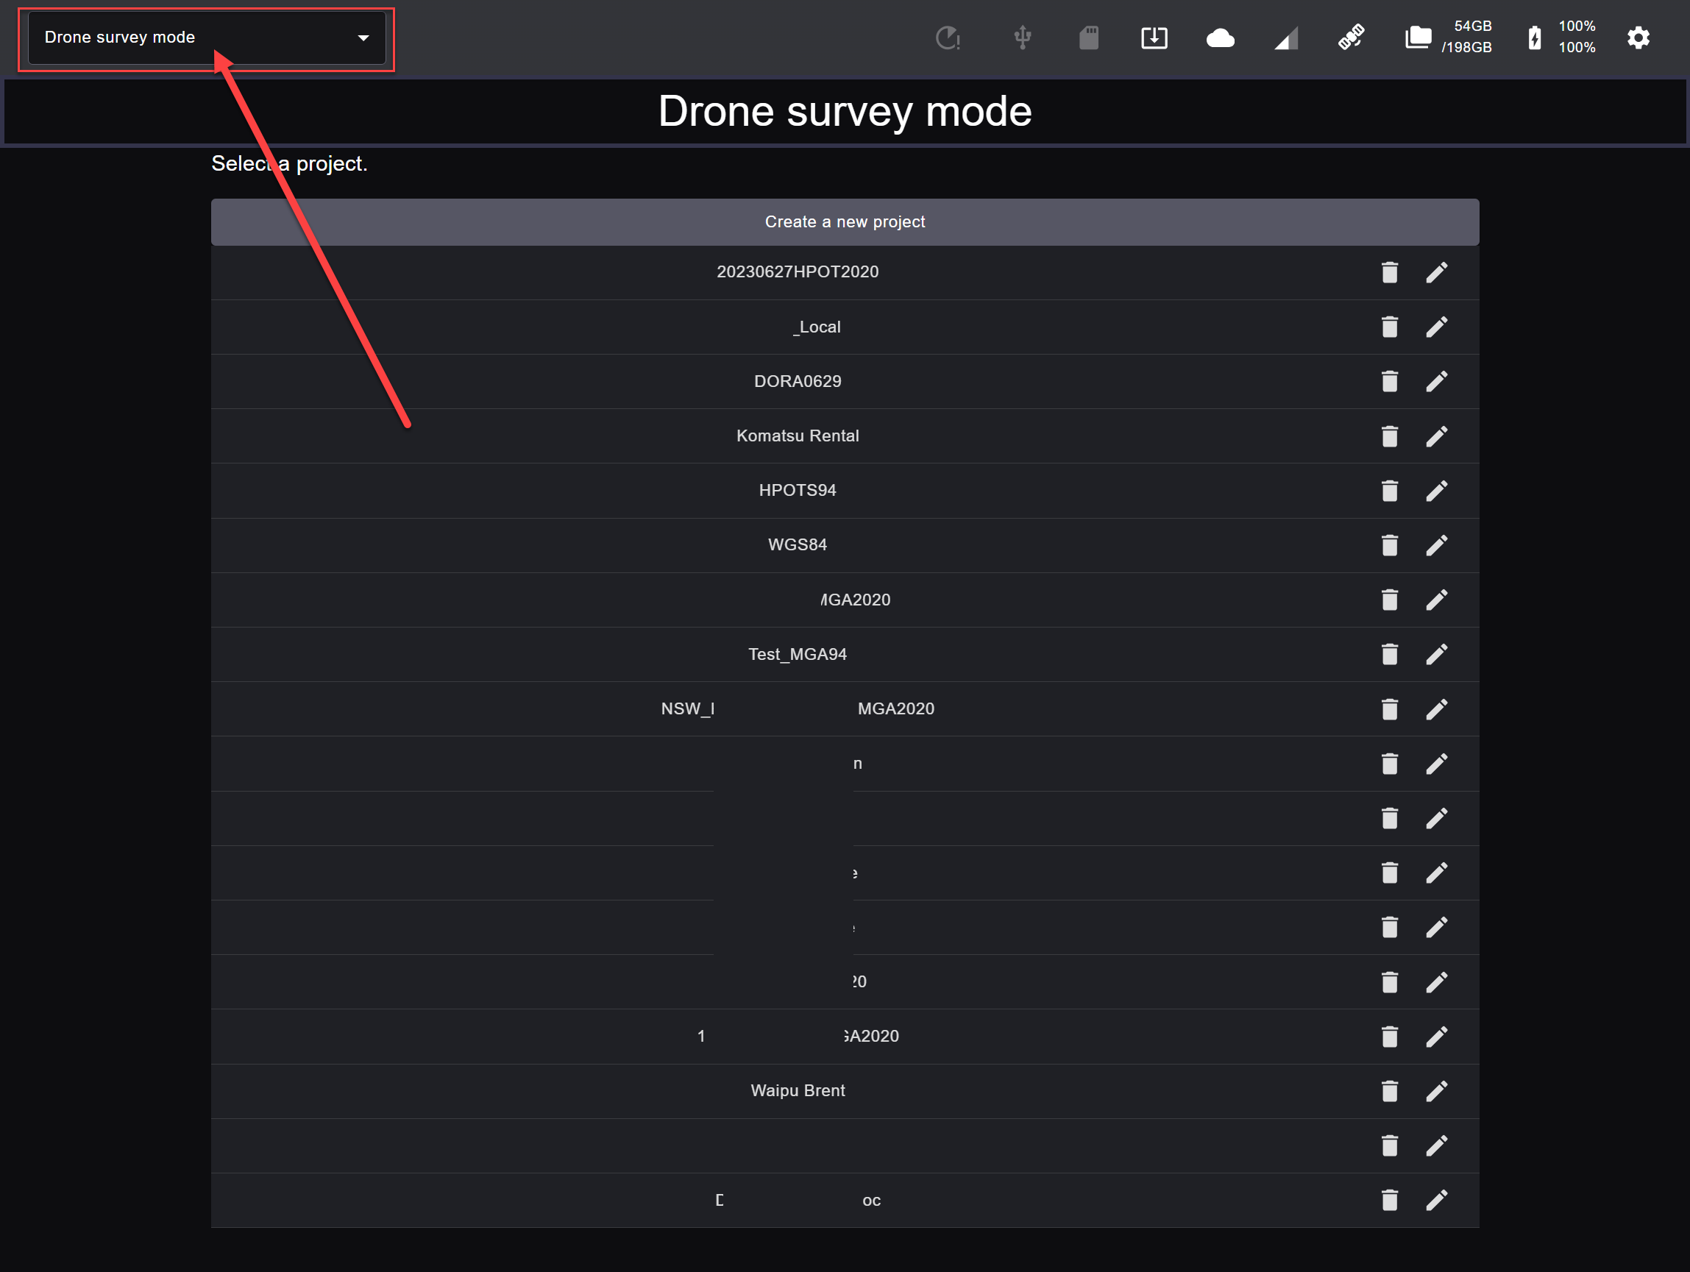
  - Use one of the following methods for a position point.
    - Self position – A network base <10km is advisable.
    - Know point – Input known Coordinates
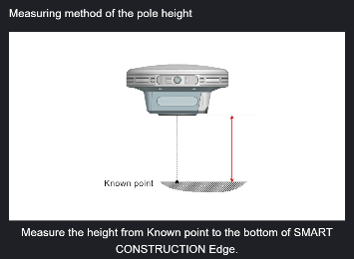
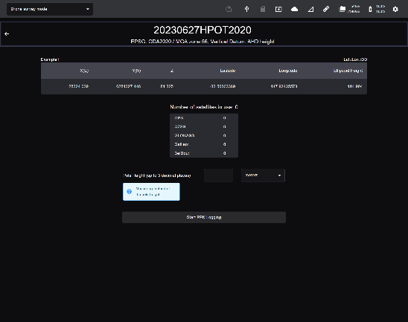
    - Use an existing point previously saved (Only Manual Input Points has a Tape Measure Option)
    - Select Start PPK logging.

Setup & Fly Drone (P4rtk)
- Place drone in clear open flat space for launch. Away from objects and metal.
- Use a clean Extreme SD card (read write speed of >90mb/s)
- Use Fully Charge Intelligent battery and controller batteries.
- Turn drone on and conduct a compass calibration. Compass calibration on each new Site
- Wait 3min after each new battery power on before launching. (PPK only)

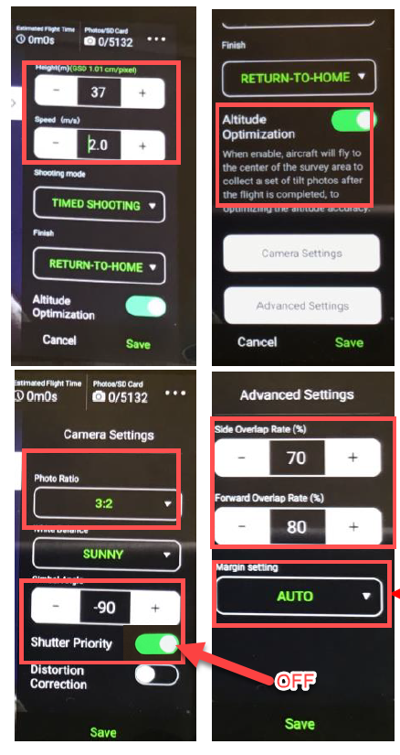
P4rtk Settings:
Select height appropriate to job (40 – 120 m – ensure clear of
obstacles)
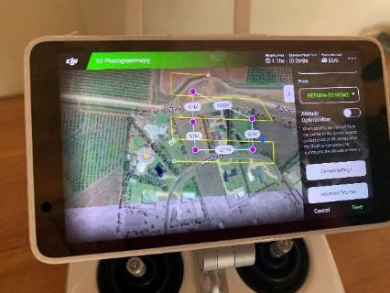
- Camera Settings
- Pick type of day
- Must be “Timed” Mode
- Altitude Optimization ON
- Ensure shutter priority & distorting correct are OFF
- Press SAVE
- Advanced settings (press)(Optional)
- - Side Overlap: 70 (60 may be used if for flat even terrain) 70 is recommended for undelated & detail survye & Cloud SfM.
- - 80 + forward (Always 80)
- Save (press)
To avoid disappointment use 70/80
- Select Parameters (boundaries of job)
- Tap each corner of screen (purple marked) tap & hold to move or double tap to
Remove
- Yellow dot used to change flight path direction
- SAVE & name the task

Setup & Fly Drone (Mavic3E)
- Place drone in clear open flat space for launch. Away from objects and metal.
- Use a clean Extreme SD card (read write speed of >90mb/s)
- Use Fully Charge Intelligent battery and controller batteries.
- Turn drone on and conduct a compass calibration. Compass calibration on each new Site
- Wait 3min after each new battery power on before launching. (PPK only)

Mavic3E Settings
- Camera Settings
  - Aircraft Model: “M3E Series” - Must
  - Camera Model: “M3E” - Must
  - Lens: “WIDE” - Must
  - Mode: S “Shutter Priority” ON - Must
  - Auto Exposure - Must
  - Shutter Speed: 1/1000(In low Light consider lowering to 500-800 as well as slowing the aircraft speed)
  - Focus Mode: MF - Must
  - Image Ration: 4:3 - Must
  - Image Format: Jpeg - Must
  - Lock Gimbal: Enabled - Must
  - Mechanical Shutter: Enabled - Must
  - Dewarping: Disabled – Must
  - Wide 1.0 X – Must

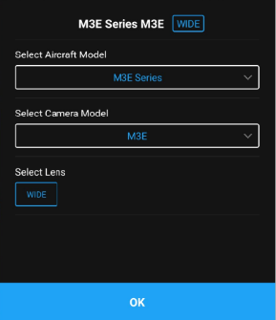
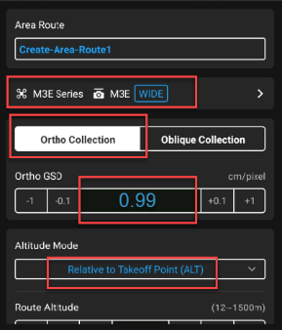
- Flight settings:
  - Controller: Set to “N”
  - Aircraft Model: “M3E Series” - Must
  - Camera Model: “M3E” - Must
  - Lens: “WIDE” - Must
  - Select: “Ortho Collection” - Must
  - Ortho GSD: 0.99 is recommended for optimum accuracy (Be aware of obstructions that could cause a crash)
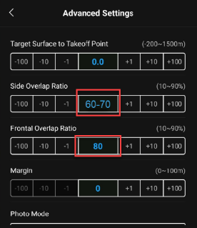
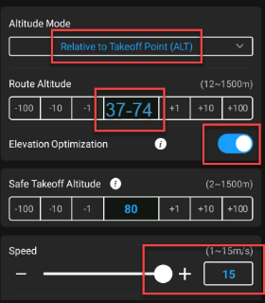
  - Altitude Mode: “Relative to Take-off Point (ALT)”
  - Route Altitude is the same as Ortho GSD: 37m is recommended for optimum accuracy (Be aware of obstructions that could cause a crash)
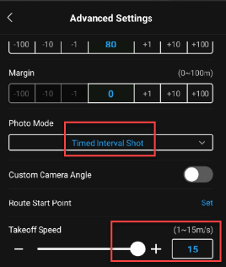
  - Side Overlap: 70 (60 may be used if for flat even terrain) 70 is recommended for undelated & detail survye & Cloud SfM.
  - Front Overlap: 80 – Must
To avoid disappointment use 70/80
  - Photo Mode: Timed Interval Shot – Must
  - Other Camera Settings:
    - Image Ratio: 4:3
    - Image Format: JPG
  - White Balance: Auto

Make sure the camera settings always matches as pictured below
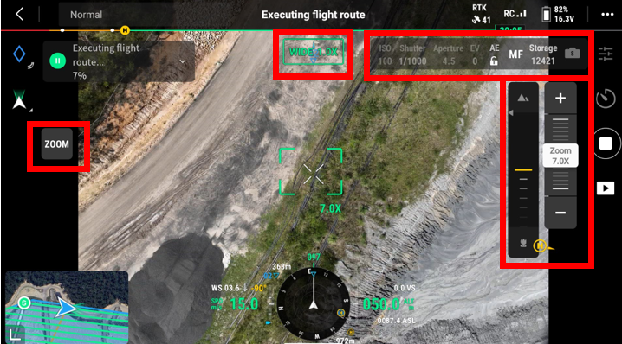

Confirm before take-off
- Set White Balance: Auto
- Dewarping: OFF
- White Balance: Auto
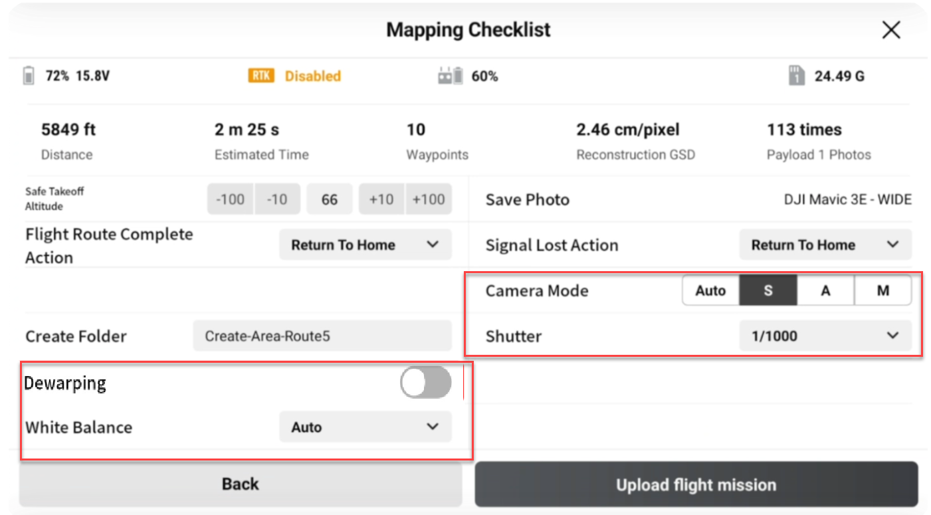

When performing PPK flight RTK settings should be off
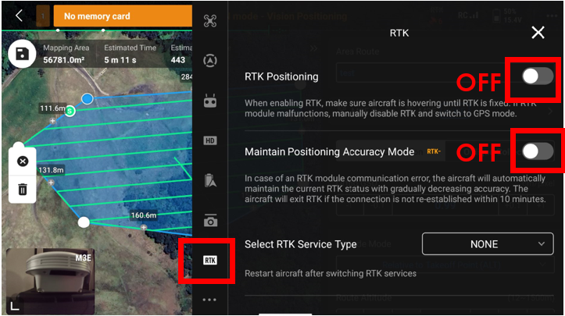

Base station Function
- Place the Edge in Clear Open elevated position.
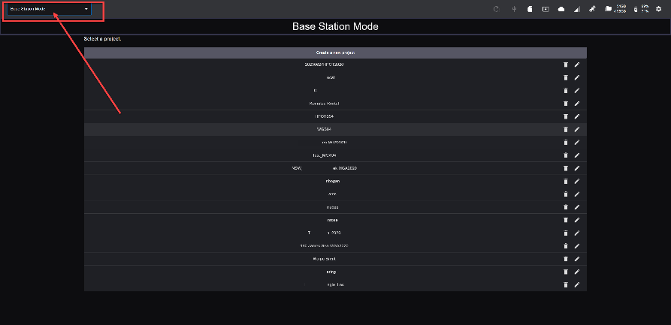
- Switch to Base Mode from the home screen.
- Select your project.
- Select your control point that you are starting the SC Edge2 on. If a different height is used input the tape measured height. (Only Manual input point has Tape Measure function)
- Choose method of RTK casting, LTE(For Modem Cellular), Wifi, External Radio( UHF, Requires Radio attached set to TX) Komatsu is not responsible & does not take responsibility for your compliance of transmitting frequency & parameters.
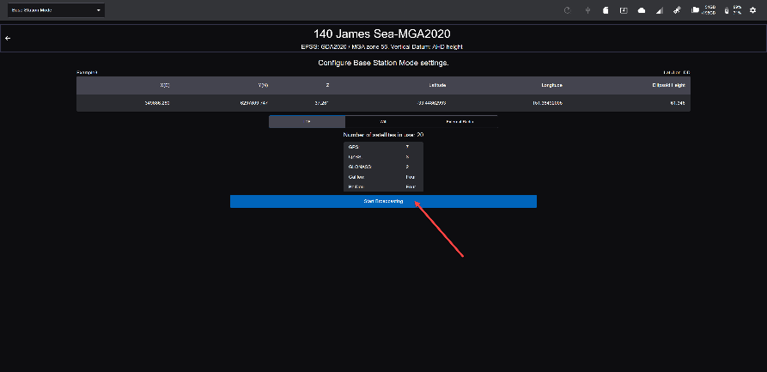
- Start Broadcasting

Processing your data
- In Drone Survey Mode select your project
- Insert the SD card into the SD slot
- Select Generate Point Cloud
- Name your drone flight and choose PPK then Next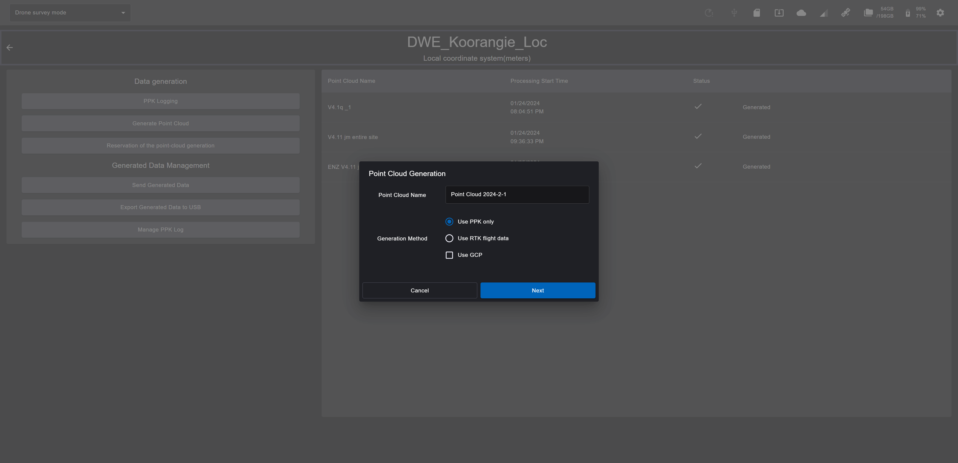
- Import all folders containing your drone flight
- Select all folders that should used for processing , press next
- Select data outputs. Recommend:
  - Unnecessary Items Removal ON . Expand Categories and tick on if you would like to leave Short Grass or Road Surfaces.
Amount of Photos Parameter indication: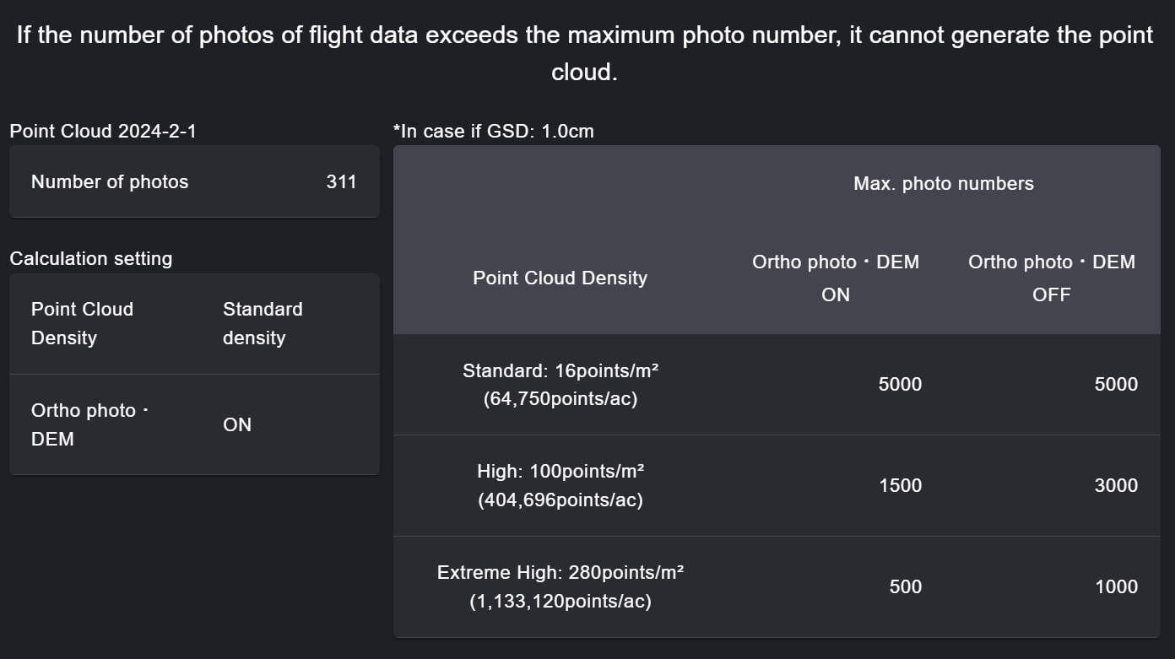
  - 16ppm recommended for sites up to 50Ha
  - Turn Orthophoto on if required. (Leave it off for quicker point cloud data aprox 50% faster)
- Start PPK Processing. Processing time varies depending photo count 1- (This is not the final step, You need to confirm processing after PPK processing)
- Confirm PPK fix rate and press Generation Starts 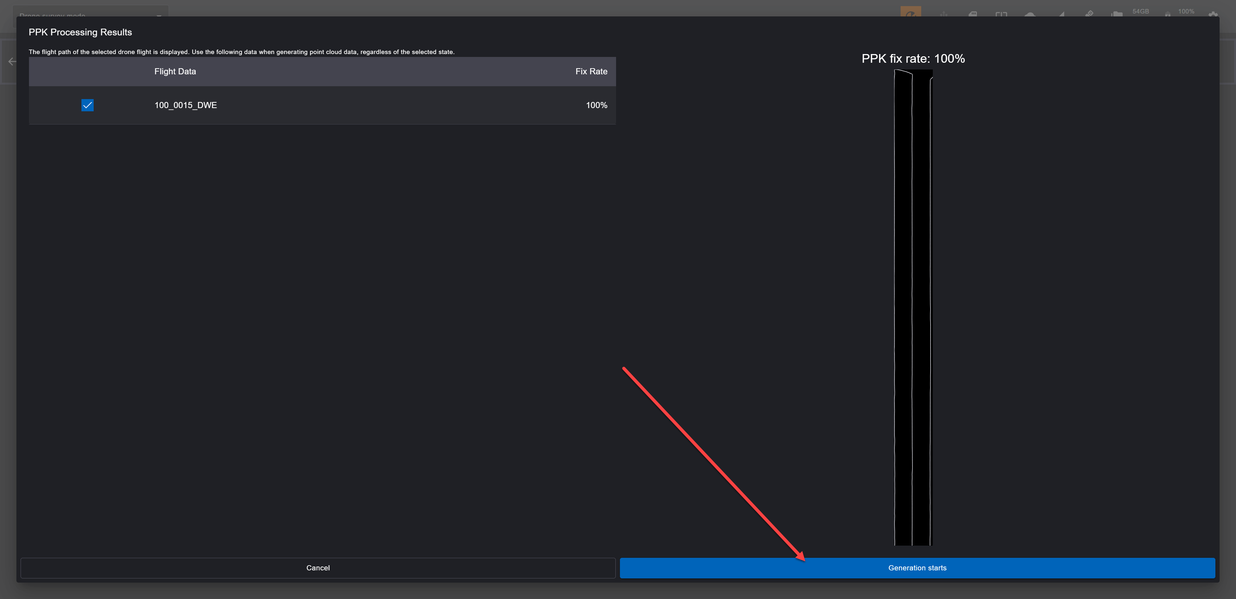
- Check the data and set the Filter of Unnecessary Item removal 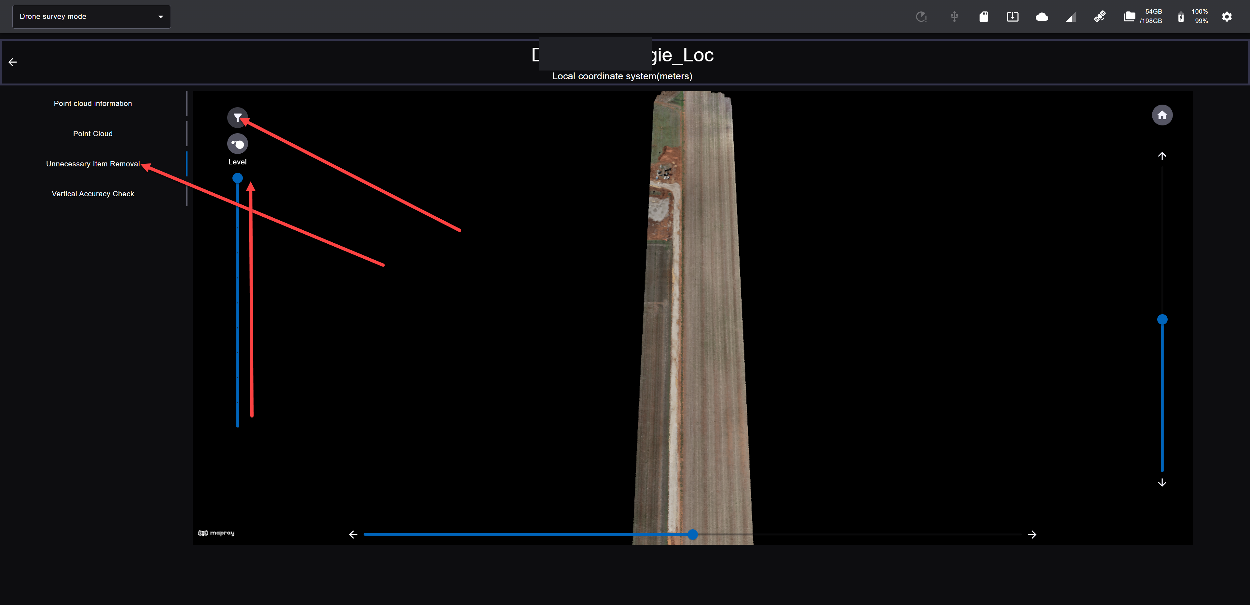
- Perform accuracy check & adjust if desired or manual adjust by inputting a value. Perform accuracy check & adjust if desired by pressing Accuracy check. Press start and then press Edit the offset value ON and input the value. Press Reflect to adjust the point cloud 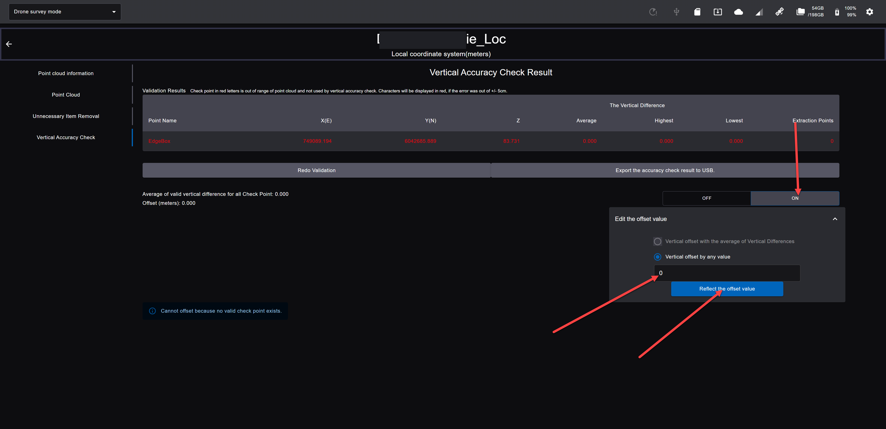

- Exporting the data:
  - Press Export Generation Data to USB 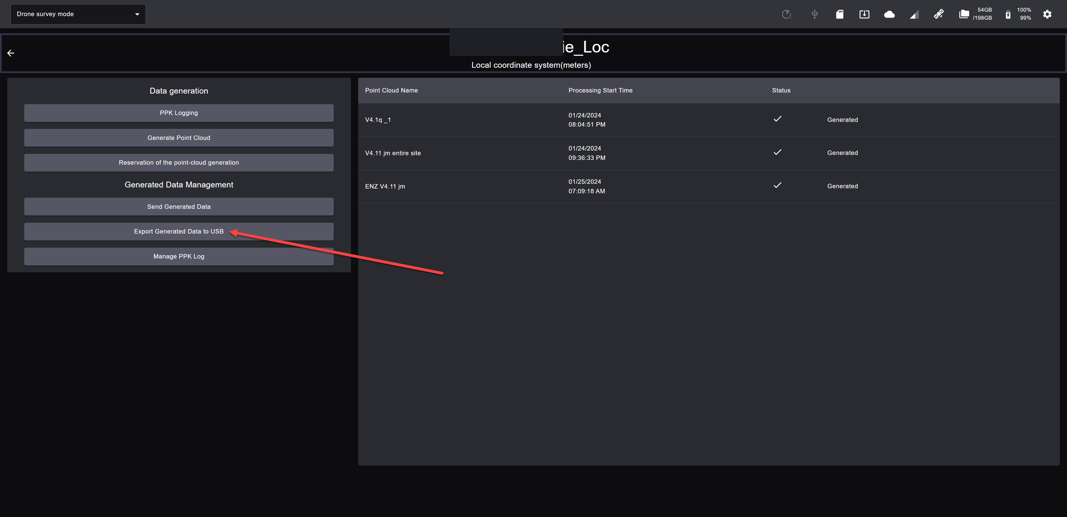
  - Insert USB into the USB port (If you are broadcasting RTK bake sure to use the USB converter to avoid broadcast interference)
  - Select the dataset to export, set to Project Coordinate System & TXT. Press Export 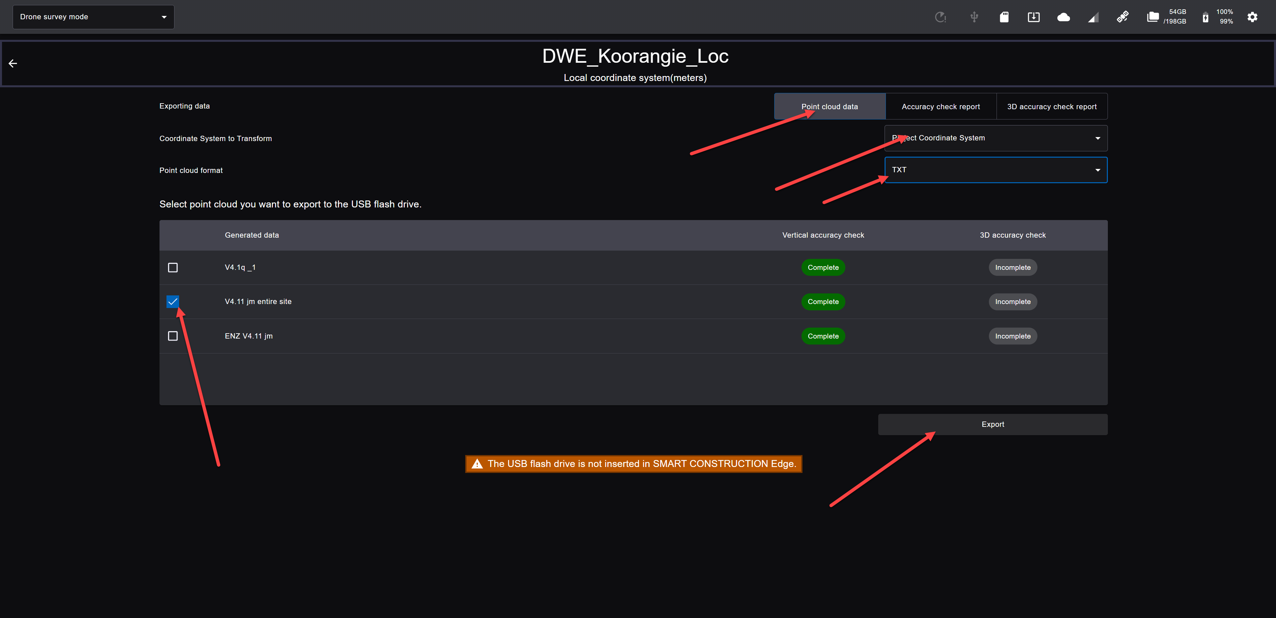
  - Wait for the data export to finish, Eject the USB and upload to the corresponding SC Dashboard site

Appendix

For iPad - Install and configure certificate
- From the tablet (iPad) home screen, tap the Safari icon and enter the following in the Safari address field
http://scedge.local
Tips
The following two-dimensional bar codes can be used to access to the URL above.

- Tap "Install Certificate" on the screen.
- Follow instructions on the screen to download it.
- Return to the Home screen and tap “Settings” icon.
- Tap on the displayed "Profile downloaded" message and follow the on-screen instructions to install
- Tap General - About - Certificate Trust Settings in the settings screen to enable ##SC EdgeBox CA for Dev##.

Add a tablet app to your home screen
- Start Safari on your iPad and access http://scedge.local.
- Tap "Launch App" 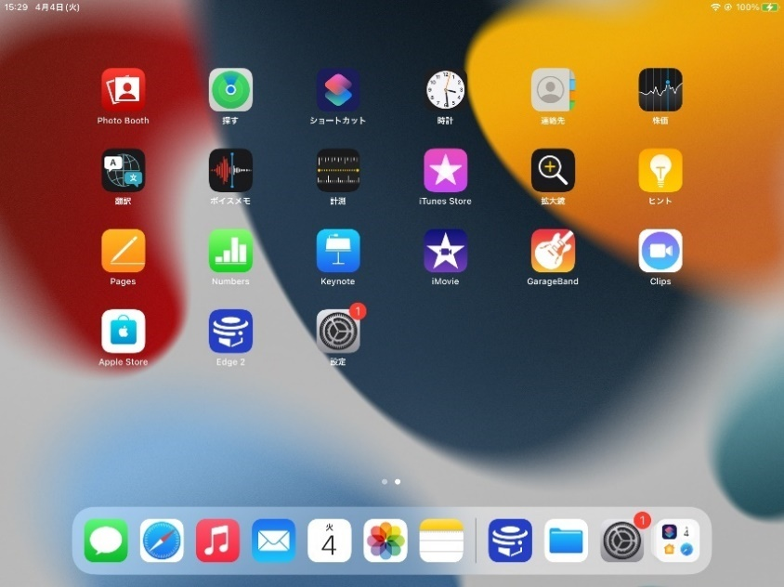.
- After the top page of the App displayed, tap Share icon in Safari, then tap “Add to Home Screen”
An app icon will be added to the home screen, and you can start the app by tapping this icon next time.

For Android or Laptop
- Use the URL: https://scedge.local
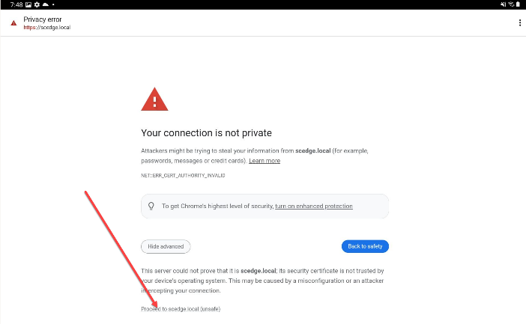
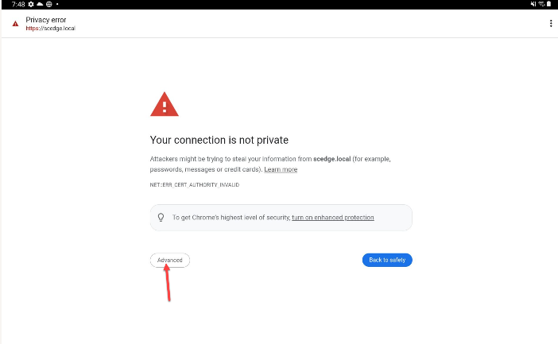
- Press Advanced and Proceed to scedge.local

Specification
Items |  | Specification | Remarks
Temperature Range | Operating | -20℃〜50℃
Temperature Range | Charging | 0℃〜45℃
Temperature Range | Storage | -20℃〜50℃
Input voltage |  | 19.5V DC
Power consumption | Standard | 13.3W | When broadcasting RTK correction data via LTE modem
Power consumption | Maximum | 87.5W | When generating a point cloud while charging the batteries.
Electrostatic resistance |  | ±8kV
Operating hours |  | Approx. 12 hours | When broadcasting RTK correction data via LTE modem
Charging hours |  | Approx. 5 hours | Charging with EdgeBox and attached power cable.
Dust-/Water-proof performance* |  | IP65 or equivalent | Tested by a third party

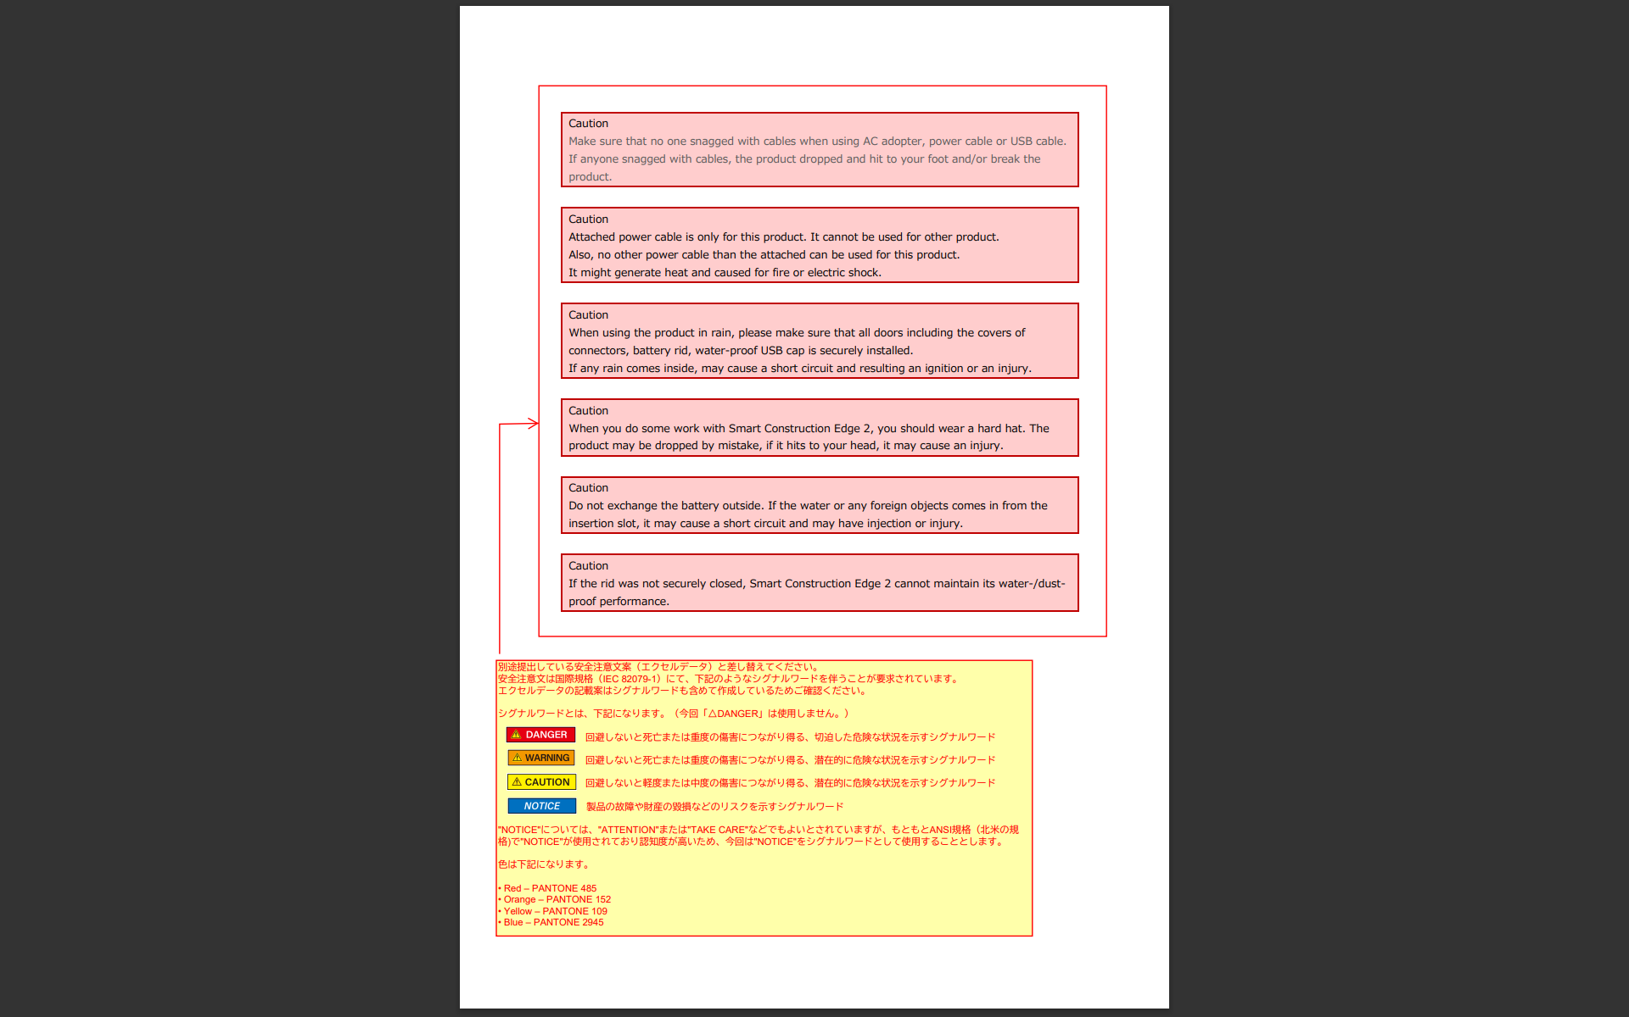
* Smart Construction Edge has a certain dust- / water-proof performance, but was not applicable for full submergence, high-pressure cleaning, some liquid, such as, detergent, seawater, beverages, and so on. And Power cable including AC adapter are not water-proofed.]
Examples of Signal word

Warnings & Other Notices
Do not replace the battery outside. If the water or any foreign objects comes in from the insertion slot, it may cause a short circuit and resulting an ignition or an injury.

Always wear a hard hat during the work.
If you dropped the product from the top of the tripod by mistake and hit to your head, it may cause an injury.

DO NOT leave the product in hot place (beside the fire, heater, inside a vehicle with a high temperature) with the battery in it.
The batteries may damage and resulting an ignition or an electric shock.

DO NOT charge the product with a wet condition by water or any liquid (such as rain)
If the electrode get wet, it may cause a short circuit and resulting an ignition or an injury.

When using the product in rain, please make sure that all doors including the covers of ports, battery rid, water-proof USB cap is securely installed.
If any rain comes inside, it may cause a short circuit and resulting an ignition or an injury.

DO NOT connect to an external radio with USB-Serial conversion cable.
It may cause a short circuit and resulting an ignition or an electrical shock.

DO NOT put any foreign objects to the SD card slot, the SIM card slot, the USB slot or the ethernet port.
It may cause a short circuit and resulting an ignition or an electrical shock.

Wearers of a pacemaker or a defibrillator should not approach to the product.
Its electric wave may have a negative effect to its operation.

The main unit should place a stable, flat place.
If it was placed at unstable place, it may be dropped and cause a damagre or a breakage.

Make sure that no one snagged with cables when using AC adopter, power cable or USB cable.
If anyone snagged with cables, the product dropped and hit to your foot and/or break the product.

If the product is used outdoors under the scorching sun for a long time, the product may become hot and the power supply may be automatically shut off.
This is due to the high temperature abnormal processing function, not the failure.
If the power is automatically cut off, wait a few minutes and press the power button again.

Do not cover the main unit with a plastic bag in rainy weather.
The temperature of the device may rise, triggering the overtemperature abnormality handling function and cutting off the power.

Do not wrap the main unit with a cloth while charging.
Heat may accumulate inside the main unit, causing malfunction or damage.

If the main unit interferes with radio or TV reception, turn off the main unit and move it away from the radio or TV.

About batteries
DO NOT leave the battery in hot place (beside the fire, heater, inside a vehicle with a high temperature) with the battery in the product.
The batteries may damage and resulting an ignition or an electric shock.

DO NOT throw the battery into a fire or heat it.
If you throw it into the fire, it will burst and it will be very dangerous. Heating may cause liquid leakage, explosion, or ignition.

DO NOT disassemble or modify the battery.
Doing so may cause chemical burns from the contents or cause it to burst and catch fire. In addition, modification may impair the function of preventing danger, causing a heat generation, an explosion, or an ignition.

DO NOT let the battery get wet.
Wetting with liquids such as water, seawater, or juice may break the protection circuit and cause a heat generation, an explosion, or an ignition.

If the battery leaks, keep it away from fire.
If the leaked electrolyte ignites, it may burst or ignite.

DO NOT apply strong impact to the battery or pierce the nail.
If it damage the protective function, it may cause an overheating, an explosion, or an ignition.

Charge the battery as described in this manual.
Charging in any other way may cause a heat generation, an explosion, an ignition, etc.

Do not allow conductive foreign objects (such as metal) or liquids to come into contact with the battery terminals.
It may cause a short circuit and resulting a heat generation, an explosion, or an ignition..

When not in use for a long time, remove the battery from the main unit.
Leaving the battery in may result in over-discharge and shorten battery life.

About the AC adopter
Attached AC adopter is only for this product. It cannot be used for other product.
Also, no other power cable than the attached can be used for this product.
It might generate heat and resulting an ignition or an electric shock.

Do not use the AC adapter outdoors.
If a foreign object or liquid gets on the terminals, it may short-circuit and cause an ignition or an electrical shock.

Do not use the AC adapter cord improperly, such as pulling, tying, bending, or stretching. In particular, when winding the cord around the AC adapter, wind it loosely rather than tightly wrap it.
It may cause an electrical shock or an ignition.

Do not use the AC adapter cord if it is damaged.
It may cause an electrical shock or an ignition.

When unplugging the power plug from the outlet, hold the power plug without holding the cord.
It may damage the cord and cause an electrical shock or an ignition.

Make sure the SD card is oriented and insert it straight.
If you force it, it may damage the SD card or this product. Also, if you accidentally insert it and cannot take it out, please contact your Komatsu distributer. If you insert tweezers and try to forcibly remove them, there is a risk of a short circuit.

Hardware specification
Items |  | Specification | Remarks
External dimensions | Width x depth x height | 300 x 300 x 150 [mm]
Body weight | Including battery | Approx 4.0㎏
Body weight | Excluding battery | Approx 2.7㎏
Total weight | Including carry case and accessories | Approx 8.3kg
Housing material | Top cover | AES
Housing material | Main frame | Magnesium die casting
Housing material | Bottom case | Magnesium die casting
External I/F | USB connector | USB3.1 x1
External I/F | USB connector | USB2.0 x1 | Waterproof connector
External I/F | SD card slot | UHS-Ⅰ SDR104 | Standard size
External I/F | SIM card slot | Nano SIM
External I/F | LAN port
SoM | Jetson Xavier NX
SoM | GPU | 384コアNVIDIA Volta,  48 Tensor core
SoM | CPU | 6コアNVIDIA Carmel ARM v8.2 64bit,6MB L2+4MB L3
SoM | RAM | 16GB 128bit LPDDR4x 59.7GB/Sec
SoM | EMMC | 16GB
Storage | SSD | 256GB
Network | Wired LAN | 10/100/1000 BASE-T
Network | Wireless LAN | 2.4GHz 802.11b/g/n
Network | LTE | LTE-FDD：B1/B2/B3/B4/B5/B7/B8/B12/B13/ B18/B19/B20/B25/B26/B28  LTE-TDD：B38/B39/B40/B41  WCDMA：B1/B2/B4/B5/B6/B8/B19  GSM：850/900/1800/1900 | Overseas  SIM free
GNSS | GPS | L1C/A, L2C
GNSS | QZSS | L1C/A, L2C
GNSS | GLONASS | L1OF, L20F
GNSS | Galileo | E1B/C, E5b
GNSS | BeiDou | B1l, B2l

